|  |
| --- |
| Circle Language Spec: Commands |

## Command Calls in an Inactive Clause in a Diagram

This article demonstrates a situation of command objects.

This article illustrates how command calls in an inactive clause look in a diagram.

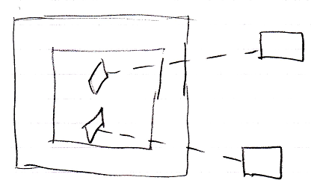

The large square is the command definition the clause is in. The square inside of it, is the inactive clause. It contains two diamonds, which are the command calls inside the inactive clause. The diamonds redirect their command definition with a class line, a dashed line, connected to the squares on the right, which are the command definitions, that are called.